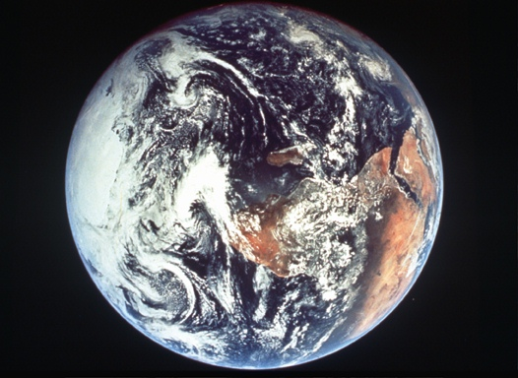

The Earth from Space
Photos of the Earth as a single, limited, fragile entity in inhospitable space have inspired
the search for human unity and global sustainability.

14.1 The Biggest Problem in the World

Sustainability and Sustainable Development deal with quite simply
the largest and most extreme problem ever faced by humanity.
What will be the future outcome of our species? What do we have to do, to ensure our survival over the long-term? Can we control our collective destiny on this earth?

We are currently experiencing the Sixth Mass Extinction. The others happened before our time, including at the end of the Permian (90% of species extinct) and Cretaceous (extinction of dinosaurs). Sadly, this time most of the loss of our planet’s biodiversity is the fault of human beings. Habitat destruction and fragmentation (land clearing, logging of wilderness areas, damming rivers), introduced species, pollution, global warming etc… at the same time wasting money on war (destruction) and dubious entertainments (distraction).

A few leading scientists have predicted a double-digit percent likelihood of human extinction by the end of the century. You can find anyone with some opinion or another, but do they know what they’re talking about? If they are even remotely right…
shouldn’t we be a little bit worried??
But what can we do?
Everything!!
With modern knowledge, freedoms and strong ethical convictions we can turn it around.
A career in environmental science, ethical philosophy or human rights might help! But even despite the ‘money’ temptation, careers in business, science, law and politics can deliver environmental and social wellbeing, sustainable technologies and more ethical value systems.

Q1: Everyone dies. But can Homo sapiens, the human species, go extinct?
What might cause it?
How likely do you think it might be over short, medium or long time-scales?
What are the alternatives to extinction?

14.2 What about the kids?

“Sustainable Development”

Sustainable development is a phrase, a symbol, a slogan, a concept, a process, an action, a pathway, a guideline, a desire, a motivation, a mechanism, a measurement, an interpretation, a relationship, an interaction, an aim, a method, a result, an outcome, as well as many other possible interpretations.

Sustainable development was first mentioned in: I.U.C.N. (1980) World Conservation Strategy: Living Resources Conservation for Sustainable Development.
I.U.C.N. (World Conservation Union), Gland, Switzerland.

The first widely recognized definition was in ‘The Brundtland Report’:
World Commission on Environment and Development (W.C.E.D.) (1987)
Our Common Future.
Brundtland, Gro Harlem (editor), Oxford University Press, and is:

“Sustainable development is development that meets the needs of the present
without compromising the ability of future generations
to meet their own needs.”

There’s a lot more to it, and people have been redefining it, deciding on its principles and arguing over its goals ever since. This original aspect is still central, and has been shortened to the phrase:
“Inter-generational Equity”
meaning equity between present people and future generations.
Since equity means fair and equal wealth, wellbeing, environment and opportunity,
and since future generations are you, and your children and their children…
it can be simplified even further to

"What about the kids?"

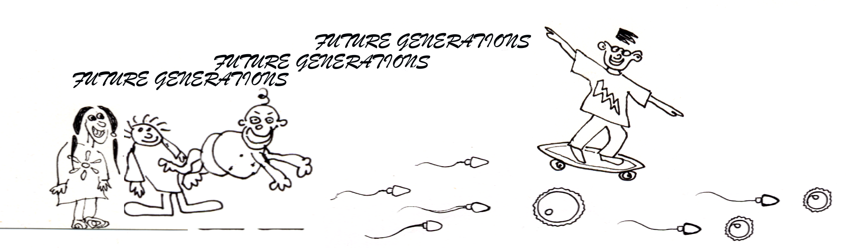

Q2: Most recent definitions and principles of ‘Sustainable Development’ have also
included “Intra-generational Equity”, or equitable distribution within
the current generation.Discuss some major ethical and practical differences between Inter-generational equity and Intra-generational equity.

14.3 Slippery Terminology



‘Sustainable Development’ has been a slippery term to nail down, and defining it has caused much heated debate and controversy (see Table 1). But it shouldn’t really be all that confusing - if it isn’t deliberately veiled or defined in a vague way (as some who prefer the status quo have attempted to do!).

To ‘sustain’ is to support, cause to continue, keep in existence and maintain at a certain standard or level.


‘Sustainability’ is a measure of how well policy and management live up to the principles and philosophies of sustainable development.
Sustainability can also be thought of as a wonderful imaginary place or ultimate objective where all good requirements are met for sustaining ecosystems and maintaining human wellbeing.



‘Sustainable’ (as well as meaning ‘able to be sustained’), refers to the level at which a resource may be harvested or depleted such that it is able to replenish (sustain) itself indefinitely (for example the catch of a fishery, timber yield in forestry, or agricultural productivity).

The sustainable yield is an uncertain threshold level at which a population or resource will not be at risk of overall long-term decline.


‘Development’ is any activity or progress which increases the wellbeing of humans and the environment. Too often it is accidentally or deliberately confused with the concept of growth (particularly economic growth including consumerism and commercialism). But growth isn’t always development, which must include things like reduction of poverty and increased quality of life, modernization, equity, health, democracy, freedom , fair trade and conservation (see Table 2).

‘Sustainable development’ has most commonly been used in specific reference to the sustainability of ecosystems. For example, the Australian government has incorporated the term ‘ecologically sustainable development’ as an official aim of policy (see Table 3), although environmental groups feel some principles are missing, and there’s still a long way to go in practice!

The environment is much more than nature and biodiversity. It also includes the human environment, including social, cultural, economic, political and informational components, all included in ‘environmentally sustainable development’.

Oh, and by the way, this is one of the reasons why environmental science is such a fascinating career to choose - it includes the big and the small, the concrete and the abstract, humans and nature - and it’s never short of interesting and vitally important issues!


Despite all these inclusions, sustainable development is a term still often abused and misrepresented. It’s even been accused of being an ‘oxymoron’, a strange word describing a self-contradictory phrase, where seemingly opposite words combine to suddenly make sense.
Q3: Sustainable development is a little ambiguous - a fuzzy concept which often means
different things to different people. Is the term ‘Sustainable Development’ self-contradictory? Why and/or why not?
Do differing interpretations help it to become a more useful and popular phrase, or do they make it less useful and practical?

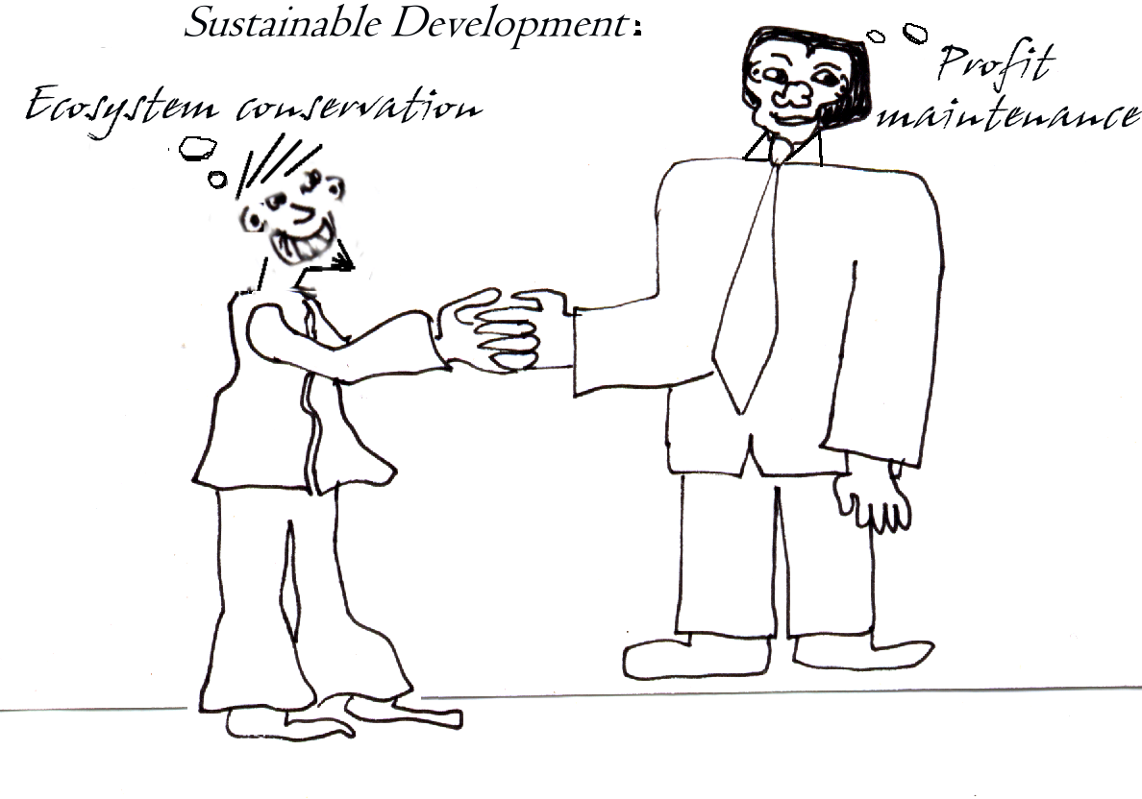

Table 1: Landmark Events and Definitions

most of previous history - barbarism reigns
1948 - Universal Declaration of Human Rights
1970 - UNESCO Man and the Biosphere Program
1972 -Club of Rome The Limits to Growth
1980 - IUCN World Conservation Strategy
1987 - WCED Brundtland Commission Our Common Future
1990 - Commonwealth of Australia Ecologically Sustainable Development Working Groups
1992 - UNCED Rio Earth Summit, and Agenda 21
1992 - United Nations Commission on Sustainable Development
1993 - Commission of the European Community Fifth Environmental Action Programme
1994 - IUCN / IIED Strategies for National Sustainable Development
1994 - United Nations Conference on Population & Development
1995 - United Nations Conference on Social Development
1996 - Earth Council Making Sustainability Work strategy
1996 - Earth Network for Sustainable Development website
1997 - Rio+5 Forum
1997 - Earth Summit+5 review
1997 - Kyoto Conference on Climate Change, Kyoto Protocol
1999 - Seattle WTO Conference anti-globalization protest gathering
Millennium Earth Initiative
2000 - time to contemplate embarking into the 21st century
2000 - Earth Charter (revised after non-adoption at 1992 Rio Earth Summit)
2001 - United Nations Millennium Ecosystem Assessment
2002 - Johannesburg World Summit on Sustainable Development
2002 - International Criminal Court
now - time to turn all this talk into action!

Table 2: Measures of National Progress and Development

Gross National Product (GNP) and Gross Domestic Product (GDP) - overused annual indicators based only on economic measures, they do not measure sustainable development or wellbeing because they include any monetary activity even if environmentally destructive or non-sustainable.

Genuine Progress Indicator (GPI) - an economic measure comparable to the GNP, but including estimates of 24 elements of social wellbeing like income distribution, leisure time, crime, environmental damage and volunteer work. Has been declining in many ‘developed’ countries.

Human Development Index - United Nations Development Programme (UNDP) quality of life indicator which combines economic output, life expectancy, literacy rate and education enrolment.

Human Freedom Index - United Nations Development Programme (UNDP) index of 40 rights and freedoms, like freedom of speech, gender equality, homosexual rights and freedom from torture.

Index of Social Health - developed by the Fordham Institute, this index includes measures such as infant mortality, teenage suicide, homicides, unemployment, health access and child poverty.

State of the Environment (SoE) Reporting - environmental reviews used by OECD countries.

Table 3: Summary of Ecologically Sustainable Development
adapted from: Ronnie Harding (1998) Environmental Decision-Making pp. 27-29

Ecologically Sustainable Development  Principles and Objectives | Recommended by:  Government Environment  Groups
1. Integration of Economic and Environmental Goals in Policy | √
2. Inter-Generational Equity | √ | √
3. Conservation of Biodiversity and Ecological Integrity | √ | √
4. Recognising the Global Dimension  {Integration} | √ | √
5. Dealing Cautiously with Risk and Irreversibility  {Precautionary Principle} | √ | √
6. Appropriate Valuation of Environmental Assets | √ | √
7. Efficiency | √ | √
8. Economic Resilience  {increases capacity for Environmental Protection} | √ | √
9. International Competitiveness and External Balance | √ | √
10. Community Participation | √ | √
11. Constant Natural Capital and ‘Sustainable Income’ |  | √
12. Qualitative Development |  | √
13. Limits on Natural Resource Use |  | √
14. Intra-Generational (social) Equity |  | √

14.4 Take a Seat for a Minute…

So, what is it we’re trying to sustain?


Sustainability must be integrated, meaning that it should be broad and all-inclusive. That’s why Francesco di Castri came up with a good metaphor: “The Chair of Sustainable Development” [Nature & Resources 31(3): 1995; 2-7]. A metaphor is a useful comparison which helps memory and understanding, and in this one the chair has four connected ‘legs’ of sustainability which must all be included in sustainable policy and management. If one leg is over-emphasised,
(usually the ‘economic leg’), then the chair won’t be flat or comfortable. Also, this is a tall Renaissance-style chair, because the Renaissance and Enlightenment were periods of Western history when integrated thinking led to some of our best discoveries. The concern now is that education is too specialised - that training only for a very specific career may not be equipping you with the broad multidisciplinary knowledge we need to solve inter-connected global problems.

Ecological Leg Economic Leg
Social Leg Cultural Leg

Biodiversity
Ecosystems
Habitats
Endangered Species
Keystone Species
Pollution & Waste
Physical Processes
Natural Resources

Institutions
Infrastructure
Education
Legal System
Health & Medical
Politics/Democracy
Military Industries
Human Resources

Religion & Culture
Ethics & Behaviour
Desires/Motivations
Entertainments
Freedoms/Rights Responsibilities
Family Values
Information/Media

Economics
Natural Capital
Goods & Services
Employment
Product Diversity
Quality of Life
Efficiency
Fair Trade/Equity

Q4: What difficulties do you think might arise in our attempts to measure such factors?

14.5 Precaution where there is Uncertainty

Uncertainty is a fact of life.

But one thing’s for sure… These causes cause those effects. Or is it affects that cause effects? Or do the processes create the properties? Oh dear… There’s this probability… It’s something to do with the context - or was that the content… What’s that difference between causation and correlation again? Confused? Actions cause impacts, measured by indicators. That’s right, got it - so long as those interactions aren’t inter-connections. That feedback is noisy… Something to do with environmental flows and that systems theory. What did I do with my network diagram? Effects can multiply when combined. Emergent properties are part of complexity theory. Risk is where the probabilities can be guessed at. A bit risky… Indeterminacy is ‘I’m afraid I don’t know’. Ignorance is ‘I don’t know what it is I don’t know’. … Apathy is ‘I don’t really care’. That’s the worst. And I don’t suppose chaos will cause any trouble this time - where’s that spaghetti…

Uncertainty is one of the reasons why many environmental management and sustainability policies sometimes fail to live up to expectations. That can be dangerous, because whether they know it or not, people rely on free but easily disrupted ecosystem services to provide critical life-support processes. If policy makers, industry and government, make mistakes providing for people, misery will result. If we make mistakes with ecology, well… you’ve heard the phrase ‘extinction is forever’. This is just one example of irreversible environmental damage.
Some ways to reduce uncertainty are measurement, monitoring and modelling. These important methods make use of indicators, which are measurements selected because they also convey information about the bigger picture.

But you can never totally get rid of uncertainty. That’s why they invented the
‘Precautionary Principle’

“Where there are threats of serious or irreversible environmental damage,
lack of full scientific certainty should not be used as a reason
for postponing measures to prevent environmental degradation.

In the application of the precautionary principle, public and private decisions
should be guided by:
(i) careful evaluation to avoid, wherever practicable,
serious or irreversible damage to the environment, and
(ii) an assessment of the risk-weighted consequences of various options.”
(definition from Intergovernmental Agreement on the Environment, Australia, 1992)

Q5: Find definitions for Risk, Uncertainty, Ignorance and Apathy.
What are the differences between them?
Can you think of any important ethical issues where each of them might
contribute to the problem?

14.6 Lean and Green

‘Sustainable Planning and Management’ is the practical application of sustainability to government policy, social planning and environmental management. It involves using principles of sustainable development in problem-solving and decision-making.
In the spirit of the ‘Chair of Sustainable Development’ introduced earlier, here’s a new metaphor, based on the ‘Leaning Tower of Pisa’ in Italy, which also uses concepts of balance and equilibrium. This model doesn’t just show what is to be included in sustainability, but the harder task of how to go about it in practical terms.

‘The Leaning Tower of Sustainable Management’

Precautionary Management Integrated Management
uses the precautionary principle to avoid includes all aspects of sustainability (see
irreversible damage (see Section 14.5) Section 14.4), including a large spatial scale
(e.g. manage whole habitats) and long time scale.
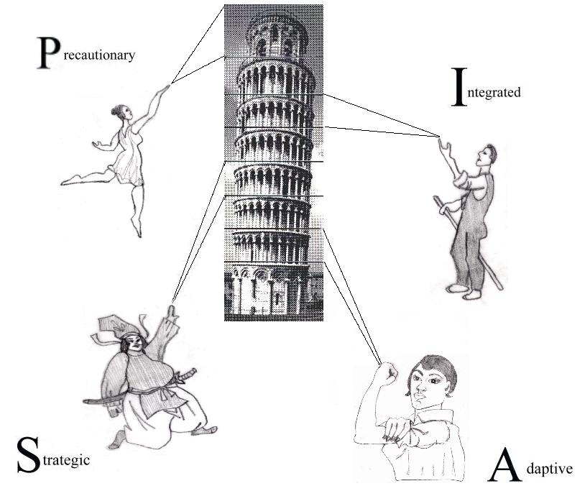
Strategic Management Adaptive Management
Strategic means well co-ordinated and goal- Adaptive means responsive to changing
directed. In this case the goal is Sustainability! circumstances (the adaptive thinker can
(If the model is ever used where this context is change his or her mind on the basis of
not absolutely clear, ‘Sustainable’ can be used new information). Flexibility is best.
in place of the term ‘Strategic’).

Q6: This question may help you to start thinking a bit like a philosopher.

Can you come up with a new model or metaphor which helps to explain something (anything) of interest to you? Simplify something abstract and hard to understand by comparing it to something more concrete and well known.

If that’s a bit hard, maybe you can come up with a new -ism (-ism is a suffix denoting a doctrine or ideology), or a new -ology (-logy is from the Greek for ‘study’ and indicates the scientific study of something).

Describe and analyse your new metaphor, model, ideology or scientific discipline.

Supplementary Question:

The Internet is an amazing tool for information-gathering and communication. Look at the Internet Resources Directory in the file Bet14sq.doc. The web-sites are sorted under the following headings:

‘Academic Literature’ | ‘Decision-Support’ | ‘Environment’ | ‘Medical & Health’
‘Activism & Charities’ | ‘Dictionaries’ | ‘Ethics’ | ‘Modelling’
‘Agriculture’ | ‘Education’ | ‘Global Warming’ | ‘Museums’
‘Biotechnology’ | ‘Election’ | ‘Internet Media’ | ‘Sustainable Development’
‘Business’ | ‘Employment’ | ‘Legal’ | ‘Translation’
‘Coastal & Marine’ | ‘Encyclopaedias’ | ‘Libraries & Books’ | ‘Web-search’

a) Can you write an essay or short answer which, somewhere, uses most or all of these words?

b) What ideas or conclusions have emerged from this exercise about the sustainability of:
(i) humanity as a whole?
(ii) your own life?

c) If you have a computer linked to the internet, visit some of the web-sites listed in the directory.
Which ones did you choose and why? Are they interesting or useful?
Are there any drawbacks to this kind of research (e.g. do some of the sites no longer exist)?

d) What has this exercise taught you about the power and future potential of information tools like the Net?

Teachers Notes

This chapter introduces the concept of sustainable development, and environmental ethics and policy. Two related chapters are chapter 6 on Car Use and chapter 7 on Ecotourism.
There is also a crossword file Betcwd.doc and the answers are below.

Literature
Ayres, Robert (1996) Statistical Measures of Unsustainability. Ecological Economics 16: 239-255.
Barrow, John D. (1998) Impossibility: The Limits of Science and the Science of Limits. Vintage, Random House, London. 279pp.
Bartelmus, Peter (1994) Environment, Growth and Development: The Concepts and Strategies of Sustainability. Routledge, London & New York. 163pp.
Bennholdt-Thomsen, Veronika and Mies, Maria (1999) The Subsistence Perspective: Beyond the Globalised Economy. Zed Books, London & N.Y., and Spinifex Press, Australia & N.Z. 246pp. (originally published 1997 in German)
Bircham, Emma and Charlton, John, eds. (2001) Anti-Capitalism: A Guide to the Movement. Bookmarks Publications Ltd, London & Sydney. 409pp.
Caldwell, L.K. (1994) Sustainable Development: Viable Concept and Attainable Goal? Environmental Conservation 21(3): 193-195
Carley, Michael and Christie, Ian (1992) Managing Sustainable Development. Earthscan Publications, London. 303pp.
Carpenter, Richard A. (1994) Can Sustainability be Measured? Ecology International Bulletin 21: 27-36
Clements, Kevin and Ward, Robin, eds. (1994) Building International Community: Cooperating for Peace Studies. Peace Research Centre, Canberra and Allen & Unwin, St Leonards NSW. 354pp.
Cocks, Doug (2003) Deep Futures: Our Prospects for Survival. University of New South Wales Press, Sydney. 332pp.
Cohen, Joel E. (1995) How Many People can the Earth Support? Norton Paperbacks, Norton & Co. New York/London 506pp+index
Commonwealth of Australia (1992) National Strategy for Ecologically Sustainable Development. Department of Environment, Sport and Territories. Australian Government Publishing Service, Canberra. 128pp.
Commonwealth of Australia (1996) Report on the Implementation of the National Strategy for Ecologically Sustainable Development (1993-1995). Prepared by the Intergovernmental Committee for Ecologically Sustainable Development for the Commonwealth Department of Environment, Sport and Territories, Canberra. 206pp.
de Graaf, H.J., Musters, C.J.M. and ter Keurs, W.J. (1996) Sustainable Development: Looking for New Strategies. Ecological Economics 16: 205-216
Deville, Adrian and Harding, Ronnie (1997) Applying the Precautionary Principle. Federation Press Pty Ltd, Sydney. 79pp.
di Castri, Francesco (1995) The Chair of Sustainable Development. Nature & Resources 31(3): 2-7
Dovers, Stephen and Handmer, John (1995) Ignorance, The Precautionary Principle, and Sustainability. Ambio 24(2): 92-97
Dovers, S.R., Norton, T.W. and Handmer, J.W. (1996) Uncertainty, Ecology, Sustainability and Policy. Biodiversity and Conservation 5: 1143-1167
Dunphy, Dexter, Benveniste, Jodie, Griffiths, Andrew and Sutton, Philip, eds. (2000) Sustainability: The Corporate Challenge of the 21st Century. Allen & Unwin, St Leonards, NSW. 282pp.
Eckersley, Richard, (1998) Perspectives on Progress: Economic Growth, Quality of Life and Ecological Sustainability. In: Eckersley, Richard, ed. Measuring Progress: Is Life Getting Better? C.S.I.R.O. Publishing, Collingwood, Victoria. 3-34; 382pp.
Falconer, Alan and Foresman, Joyce (eds. 2002) A System for Survival: G.I.S. and Sustainable Development. E.S.R.I. Press, Redlands CA. 116pp.
Frazier, J.G. (1997) Sustainable Development: Modern Elixir or Sack Dress? Environmental Conservation 24(2): 182-193
Fricker, Ally (1991) Towards a Sustainable Society: The Fallacies of the Prophets of Doom or Ostrich-Like Optimism. In: Bierbaum, Nena, ed. Towards Ecological Sustainability. Centre for the Environment and Sustainable Development, Flinders University, SA.193-198
Gatto, M. (1995) Sustainability: Is it a Well-Defined Concept? Ecological Applications 5(4): 1181-1183
Geller, D.S. and Singer, J.D. (1998) Nations at War: A Scientific Study of International Conflict. Cambridge University Press, Cambridge. 242pp.
Goleman, Daniel (1996) Emotional Intelligence: Why it can matter more than I.Q. Bloomsbury Publ., London. 352pp.
Haller, Stephen F. (2002) Apocalypse Soon? Wagering on Warnings of Global Catastrophe. McGill Queen's University Press, Montreal Canada. 185pp.
Hamilton, Clive (2004) Growth Fetish. Allen & Unwin, Crows Nest, NSW. 262pp.
Hancock, D.A., Smith, D.C., Grant, A. and Beumer, J.P., eds. (1997) Developing and Sustaining World Fisheries Resources: The State of Science and Management. 2nd World Fisheries Congress. C.S.I.R.O., Collingwood, Victoria.
Handy, Charles (1998) The Hungry Spirit: Beyond Capitalism - A Quest for Purpose in the Modern World. Arrow Books Ltd., Random House, London. 272pp.
Harding, Ronnie, ed. (1998) Table 2.1: The Objectives and Principles of Ecologically Sustainable Development (ESD). In: Environmental Decision-Making: The Roles of Scientists, Engineers and the Public. Federation Press, Leichhardt, NSW. 27-29; 366pp.
I.U.C.N. (World Conservation Union) (1980) World Conservation Strategy: Living Resources Conservation for Sustainable Development. I.U.C.N., Gland, Switzerland.
Joy, Bill (2000) Why the Future Doesn’t Need Us. Wired 8.04: 238-263 and see online: www.wired.com/wired/archive/8.04/joy.html
King, Alexander and Schneider, Bertrand (1991) The First Global Revolution: A Report by the Council of the Club of Rome. Simon & Schuster, London. 234pp.
Kuhn, Thomas (1970) The Structure of Scientific Revolutions. Second Edition, University of Chicago Press, Chicago.
Laszlo, Ervin, ed. (1997) Third Millennium: The Challenge and the Vision. The Club of Budapest Report on Creative Paths of Human Evolution. Gaia Books Ltd, London.156pp.
Levin, S.A. (1993) Perspectives on Sustainability. Ecological Applications 3: 545-589
Ludwig, Donald (1993) Environmental Sustainability: Magic, Science and Religion in Natural Resource Management. Ecological Applications 3(4): 555-558
Ludwig, D., Hilborn, G. and Walters, C. (1993) Uncertainty, Resource Exploitation and Conservation: Lessons from History. Science 260: 17-36
Macer, Darryl, ed. (in prep.) UNESCO / IUBS / EUBIOS Living Dictionary of Bioethics. Eubios Ethics Institute, Tsukuba, Japan. Full text available free online at: www.biol.tsukuba.ac.jp/~macer/biodict.htm
Martin, Hans-Peter and Schumann, Harald (1997) The Global Trap: Globalization and the Assault on Democracy and Prosperity. Pluto Press, Annandale, NSW. 269pp. (originally published 1996 in German).
Meadows, Donella, Meadows, Dennis, Randers, Jorgen and Behrens, William III (1972) The Limits to Growth: A Report for the Club of Rome’s Project on the Predicament of Mankind. Newgate Press/Potomac Associates/Pan Books, London. 205pp.
Milbrath, Lester W. (1989) Envisioning a Sustainable Society: Learning Our Way Out. State University of New York Press. 403pp.
Mill, John Stuart (1861) Utilitarianism. (first published in Fraser’s Magazine)
Moir, W.H. and Mowrer, H.T. (1995) Unsustainability. Forest Ecology & Management 73: 239-248
Moldan, Bedrich, Billharz, Suzanne and Matravers, Robyn (1997) Sustainability Indicators: A Report on the Project on Indicators of Sustainable Development. John Wiley & Sons, Chichester. 415pp.
Myers, Norman (1993) Biodiversity and the Precautionary Principle. Ambio 22(2-3): 74-79
Pearce, D.W. ed. (1991) BluePrint 2: Greening the Global Economy. Earthscan, London.
Pearce, D.W. ed. (1994) BluePrint 3: Measuring Sustainable Development. Earthscan, London. 224pp.
Pearce, D.W., Markandya, A. and Barbier, E.B., eds. (1989) Blueprint for a Green Economy (BluePrint 1). Earthscan, London.
Pugh, Cedric (1996) Sustainability and Sustainable Cities. In: Pugh, Cedric, ed. Sustainability, the Environment and Urbanisation. Earthscan Publications, London. 250pp; 135-177
Rawls, John (1971) A Theory of Justice. Harvard University Press, Cambridge, MA.
Reid, David (1995) Sustainable Development: An Introductory Guide. Earthscan Publ. Ltd. London. 261pp.
Rheingold, Howard, ed. (1994) The Millennium Whole Earth Catalog: Access to Tools and Ideas for the Twenty-First Century. HarperCollins Publishers, San Francisco. 384pp. Rheingold’s web site: www.minds.com
Rifkin, Jeremy (1998) The Biotech Century: How Genetic Commerce will Change the World. Phoenix, Orion Books Ltd London. 272pp.
Robertson, Geoffrey (1999) Crimes Against Humanity: The Struggle for Global Justice. Penguin Books (2000), Ringwood, VIC. 554pp.
Roddick, Anita, ed. (2001) Take It Personally: How to Make Conscious Choices to Change the World - A Globalization Survivor’s Guide. Thorsons/HarperCollins Publishers Ltd, London. 257pp.
Saul, John Ralston (2001) On Equilibrium. Penguin Books. 370pp.
Schumacher, E.F. (1973) Small Is Beautiful: A Study of Economics as if People Mattered. Abacus, Sphere Books Ltd, London. 255pp.
Siebenhuner, Bernd (2000) Homo sustinens - Towards a New Conception of Humans for the Science of Sustainability. Ecological Economics 32: 15-25
Singer, Peter (2002) One World: The Ethics of Globalisation. Text Publishing Company, Melbourne. 255pp.
Sivakumar, M. and Messer, J., eds. (1995) Protecting The Future: E.S.D. in Action - Proceedings of the National Conference on Successful Strategies for Ecologically Sustainable Development, University of Wollongong, 5-7 Dec. 1994. Futureworld: National Centre for Appropriate Technology Inc., Wollongong, NSW. 492pp.
Suzuki, David (1990) Inventing the Future: Reflections on Science, Technology and Nature. Allen & Unwin Aust. Pty. Ltd., North Sydney, NSW. 247pp.
Theobold, Robert (1999) We DO Have Future Choices: Strategies for Fundamentally Changing the 21st Century. Southern Cross University Press, Lismore, NSW. 300pp.
Trainer, Ted (1995) The Conserver Society: Alternatives for Sustainability. Zed Books Ltd, London. 246pp.
U.N.C.E.D. (United Nations Conference on Environment and Development) (1992) Agenda 21: A Blueprint for Survival Into the 21st Century. U.N.C.E.D., United Nations Environment Program, Rio de Janeiro.
Venning, Jackie and Higgins, John (eds.) (2001) Towards Sustainability: Emerging Systems for Informing Sustainable Development. University of New South Wales Press, Sydney. 239pp.
Weizsacker, Ernst von, Lovins, Amory B. and Lovins, L. Hunter (1998) Factor Four: Doubling Wealth, Halving Resource Use. The New Report to the Club of Rome. Earthscan Publications, London. 322pp.
Wilson, Edward O. (1998) Consilience: The Unity of Knowledge. Abacus, Little Brown & Co., London. 374pp.
W.C.E.D. (World Commission on Environment and Development) (1987) Our Common Future. Brundtland, Gro Harlem, (ed.) Oxford University Press, Oxford. 400pp. Also known as ‘The Brundtland Report’.
Yencken, David and Wilkinson, Debra (2000) Resetting the Compass: Australia’s Journey Towards Sustainability. C.S.I.R.O. Publishing, Collingwood, Victoria. 400pp.

Internet Directory (Brief version)
There is an extensive Internet Resources Directory in the file Bet14sq.doc, which also contains many references. It is not necessary to look at these references for teaching this chapter, but they are given since the list was compiled. The Bioethics Dictionary also provides some explanation of terms.

Alternative Technology Association: www.ata.org.au
Centre for Social and Environmental Accounting Research: www.dundee.ac.uk/accountancy/csear
Clock of the Long Now (10,000-year clock and library edited by Stephen Brand): www.longnow.org
CogniScope (global systems analysis methodology): www.cwaltd.com/index1.htm
C.S.I.R.O. (Commonwealth Scientific & Industrial Research Organisation, Australia): www.csiro.au/csiro/csirores.htm and www.publish.csiro.au
Environment, Development and Sustainability (journal): www.wkap.nl/journals/eds
Environmental and Resource Economics (journal): www.wkap.nl/journals/ere
Foresight Institute: www.foresight.org
Global Change Research Information Office: www.gcrio.org/
Guidelines for Assessing the Sustainability of Australian Fisheries: www.environment.gov.au/marine/fisheries/assessment/main.html
Institute for Global Ethics: www.globalethics.org/
Institute for Local Self Reliance: www.ilsr.org
Institute for Policy Studies: www.ips.dc.org
Institute of Development Studies (Devline): www.ids.ac.uk
International Council for Science: www.icsu.org/
International Geosphere-Biosphere Program: www.igbp.kva.se/
International Institute for Environment & Development (I.I.E.D.): www.iied.org
International Institute for Sustainable Development (I.I.S.D.): www.iisd.ca/
International Journal of Sustainable Development and World Ecology: www.parthpub.com/susdev/home.html
International Society for Environmental Ethics: www.cep.unt.edu/ISEE.html
I.U.C.N. (World Conservation Union): http://iucn.org
Journal of Risk and Uncertainty: www.wkap.nl/journals/jru
Mitigation and Adaptation Strategies for Global Change (journal): www.wkap.nl /journals/mitigadap
Multinational Monitor: www.essential.org/monitor/
National Science Foundation (U.S.): www.nsf.gov/geo/egch/
Nobel Prize Archive: www.almaz.com/nobel
One World (sustainability news and business directory): www.oneworld.com
Political Resources: www.politicalresources.com
Science Applications International: www.saic.com
Socio-Economic Data Application Center: http://sedac.ciesin.org
SustainAbility Ltd: www.sustainability.co.uk
Sustainability Web Ring (sustainability directory): http://www.webring.org/cgi-bin/webring?ring=sustainability;id=7;list
United Nations web site: www.un.org
U.N.D.P. (United Nations Development Program): www.undp.org
U.N.E.P. (United Nations Environment Program): www.unep.org
U.N.E.S.C.O. (United Nations Educational, Scientific & Cultural Organisation): www.unesco.org
U.N.F.P.A. (United Nations Population Fund): www.unfpa.org
U.N.I.C.E.F (United Nations Children’s Fund): www.unicef.org
White House Fact Sheet: Policy Declaration on Environment and Trade: http://sunsite.utk.edu/FINS/Sustainable_Development/Fins-SD-20.txt
World Data Center-A for Human Interactions in the Environment: www.ciesin.org /home-page/WDC.html
Workers Rights Consortium: www.workersrights.org
World Bank: www.worldbank.org
World Database of Happiness: www.eur.nl/fsw/research/happiness/
World Development Movement: www.wdm.org.uk
World Intellectual Property Organisation: www.wipo.org/eng/main.htm
World Resources Institute: www.wri.org/meb
World Trade Organisation (W.T.O.): www.wto.org/wto
Worldwatch Institute: www.worldwatch.org

14. Sustainable Development

Chapter objectives
Environmental ethics is also an essential part of bioethics. Sustainable development is a term that is often used, and this chapter aims to introduce:
1. What is sustainable development.
2. The ways that trendy terms can be used politically.
3. To consider the reasons why sustainability is necessary for survival.
4. Give arguments for environmental protection.

Sustainability Crossword Solutions

ACROSS: | DOWN:
3. Responsibilities  11. Support  15. Progress  20. Maps  22. Democracy  25. Emergent  26. Recycle  28. Utopia  29. Next  30. Uni  31. Happiness  33. Rights  34. Ethics  36. Sustainable  38. Wilderness  40. Intrinsic  42. Economics  45. Indicator  47. Demo  49. Sun  51. Long  52. Yes  53. Ism  55. Air  58. Valuation  60. Free  61. Yin  63. EIA  64. Technology  65. Gaia  67. Trees  68. Nest  69. Conserve  70. Sufficiency | 1. Positive  2. Us  4. Eg  5. Process  6. Net  7. Bioethics  8. Intra  9. Inter  10. Sustainability  12. Uncertainty  13. Poly  14. Time  15. Pre  16. Respect  17. Strategic  18. Precautionary  19. Complexity  21. Subsist  23. Renew  24. Restrict  27. Clever  28. UN  30. United  32. Sustain  35. Hunger  37. Limits  39. GMO  41. Contents  42. Ecology  43. Organic  44. Systems  46. Reality  48. Models  49. Space  50. Bio  54. Rate  56. Fair  57. Roof  59. Now  60. Fun  62. NGO  66. We

