14.1 The Biggest Problem in the World

Sustainability and Sustainable Development deal with quite simply
the largest and most extreme problem ever faced by humanity.
What will be the future outcome of our species? What do we have to do, to ensure our survival over the long-term? Can we control our collective destiny on this earth?

Q1: Everyone dies. But can Homo sapiens, the human species, go extinct?
What might cause it?
How likely do you think it might be over short, medium or long time-scales?
What are the alternatives to extinction?

“Sustainable Development”
Sustainable development is a phrase, a symbol, a slogan, a concept, a process, an action, a pathway, a guideline, a desire, a motivation, a mechanism, a measurement, an interpretation, a relationship, an interaction, an aim, a method, a result, an outcome, as well as many other possible interpretations.

Sustainable development was first mentioned in: I.U.C.N. (1980) World Conservation Strategy: Living Resources Conservation for Sustainable Development.
I.U.C.N. (World Conservation Union), Gland, Switzerland.

The first widely recognized definition was in ‘The Brundtland Report’:
World Commission on Environment and Development (W.C.E.D.) (1987)
Our Common Future.
Brundtland, Gro Harlem (editor), Oxford University Press, and is:

“Sustainable development is development that meets the needs of the present
without compromising the ability of future generations
to meet their own needs.”
This original aspect is still central, and has been shortened to the phrase:
“Inter-generational Equity”
meaning equity between present people and future generations.
Since equity means fair and equal wealth, wellbeing, environment and opportunity,
and since future generations are you, and your children and their children…
it can be simplified even further to

"What about the kids?"

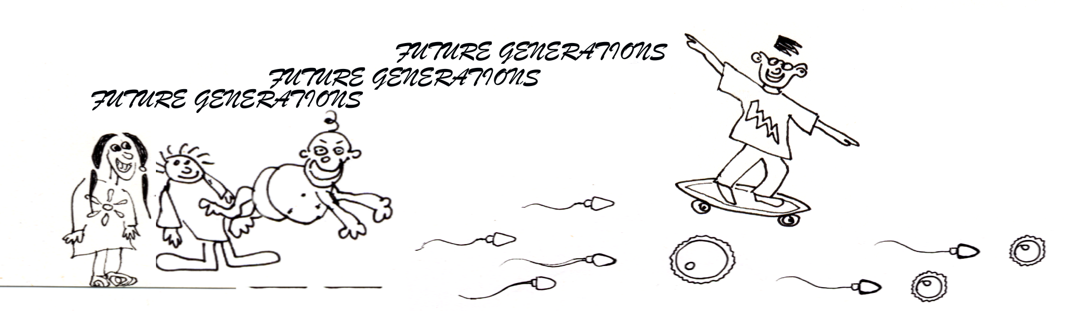

14.4 Take a Seat for a Minute…

So, what is it we’re trying to sustain?


Sustainability must be integrated, meaning that it should be broad and all-inclusive. That’s why Francesco di Castri came up with a good metaphor: “The Chair of Sustainable Development” [Nature & Resources 31(3): 1995; 2-7]. A metaphor is a useful comparison which helps memory and understanding, and in this one the chair has four connected ‘legs’ of sustainability which must all be included in sustainable policy and management. If one leg is over-emphasised,
(usually the ‘economic leg’), then the chair won’t be flat or comfortable. Also, this is a tall Renaissance-style chair, because the Renaissance and Enlightenment were periods of Western history when integrated thinking led to some of our best discoveries. The concern now is that education is too specialised - that training only for a very specific career may not be equipping you with the broad multidisciplinary knowledge we need to solve inter-connected global problems.

Ecological Leg Economic Leg
Social Leg Cultural Leg

Biodiversity
Ecosystems
Habitats
Endangered Species
Keystone Species
Pollution & Waste
Physical Processes
Natural Resources

Institutions
Infrastructure
Education
Legal System
Health & Medical
Politics/Democracy
Military Industries
Human Resources

Religion & Culture
Ethics & Behaviour
Desires/Motivations
Entertainments
Freedoms/Rights Responsibilities
Family Values
Information/Media

Economics
Natural Capital
Goods & Services
Employment
Product Diversity
Quality of Life
Efficiency
Fair Trade/Equity

Q2: What difficulties do you think might arise in our attempts to measure such factors?

