4.1. Testing for cancer gene susceptibility
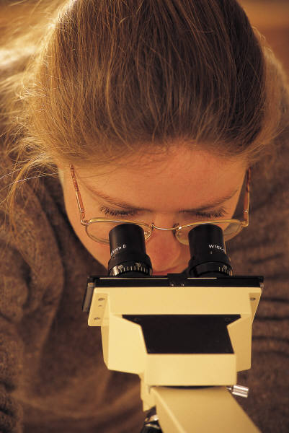

Genetic testing is based on knowing the genetic code of
cells in our bodies. The genetic code, in the
form of the chemical DNA, determines everything
from hair colour to the way we digest food.

Mutations, or changes to the structure of DNA, can
make us more susceptible to some diseases or disabilities.
Even if you have the mutation, it may not mean you get
the disease, but are just more likely to get it. The link
between having the mutation and the possibility of getting
the disease is not well understood. For example, some
genetic mutations interact with factors like a person’s
lifestyle or other environmental factors such as chemicals or sunlight.

The technology for testing for some mutations is now available. Imagine that a simple blood test could tell you if you have a mutated gene that makes you susceptible to getting cancer. There may be the possibility that you could pass this mutation on to your unborn children.

Genetic testing provides some opportunities to find out about possible health problems that may not happen for many years. Knowing whether you are more susceptible to a disease gives you the opportunity to minimize the risks, for example, making lifestyle changes.

Information from genetic testing is powerful knowledge which raises important questions:

- Do we want to know what could go wrong with our health in the future?
- How accurately does it predict the future?
- Who should be informed?
- Could this knowledge be used against someone?
- Should people be told if they do not want to know?
Trash and treasure activity
4.2. Trash and treasure activity
A researcher must dig to find words to help answer the questions (treasure) and toss aside unnecessary sentences, phrases, words, ideas as trash because they do not answer the questions and therefore are unimportant in this context.

What to do

- Choose ONE question from the list below and write it on a piece of paper.

Questions on genetic testing for cancer genes

- What are the advantages of being screened for the breast cancer gene BRCA1?
- Why do women who are tested need counselling?
- What are the implications for a person who is tested to be positive for the gene?
- What are the implications if the test is negative?

- Scan the text sentence by sentence to find the answer. Ask “Does this sentence answer the question?”
- If it does not answer the question, it is trash. Go on to the next sentence.
- If it does answer the question treasure it by writing down the words or phrase that answers the question.
- Continue to read the text until you have finished sorting the trash and treasure. Make sure you keep all the treasure as notes.

4.3. BRCA testing
Changes to the gene BRCA1 have been linked with breast and ovarian cancer. BRCA1 is a tumour suppressor gene. Tumour suppressors are genes that control cell growth. When enough cells in an area have grown, the tumour suppressors tell the cells to stop growing. When these genes don’t work properly, as in the case of mutated BRCA1 genes, the signal to stop growing is not always given, and growth continues out of control, and tumours result.
To test for a BRCA1 mutation, a blood sample is taken, and a specific change on chromosome 17q21 is searched for. Only 5% of women with breast cancer are thought to have this particular mutation.
Genetic testing can lead to early detection that could help to prolong and save lives. The information could cause havoc if it was misused or misunderstood. When a woman is told that she carries the gene, she has the following options. She could simply monitor her health. In the case of ovarian cancer this may not be enough as often times symptoms do not appear until it is too late. She could choose to have a preventative mastectomy (surgery to remove her breasts) or hysterectomy (surgery to remove either just the ovaries or the uterus and the ovaries).
Making the decision and having an operation can cause stress. People deal with stress in different ways. Some people become devastated. This may lead to anxiety attacks, depression or even heart disease.
Some people, even if they cannot change their future, find information of this sort beneficial....the more they know, the more their anxiety level goes down. But there are others who cope by avoiding, who would rather stay hopeful and optimistic and not have the unanswered questions answered. Some people feel they would have more control over their health if they knew they had inherited a defective gene. Some women might choose to have their children early in life and then proceed with a hysterectomy. And others feel they simply could not adjust to a positive test result.
This type of testing can have enormous implications on future employment or health and life insurance eligibility. Suppose a person learns that they have a predisposition to cancer, would they be forced to inform their employers and insurers about the test results? Potential employers may hold this information against them and not offer them the job. If insurance companies were given this information, premiums would increase for those at risk and life insurance may be denied.
There are also implications should a person test negative as this result may lead to people feeling that will not get cancer (complacency). A woman might decide not to monitor her health carefully, neglecting the early detection practices such as self- exam and mammography feeling that she is safe from this cancer. Complacency would be especially harmful if the test results are actually a false negative.
It is estimated that less than one in ten cases of cancer results from inherited gene mutations. Most cancers are not the result of inherited factors. Even if a mutation in a gene for a particular cancer is inherited, for example the BRCA1 gene for breast cancer, the cancer will not always develop. Also, both men and women without the gene can also develop breast cancer.

Discussion Questions
- What information does the article give to help you answer each question?
- If your sister tests positive for the BRCA1 gene, would you recommend to her that she have her breasts or ovaries removed as a preventative measure?
- What additional information do you need?
- Is it illegal in your country to use a blood sample for genetic testing even though the sample was taken for another reason?

► Write a list of risks and limitations of genetic testing.

Teacher’s notes

See also chapter 3 on genetic testing and privacy.

The Trash and Treasure - note taking activity is from Big Six lesson Plans- http://ericir.syr.edu/big6/bigsix.html
Jansen, B bjansen@tenet.edu
This procedure can be used as a discriminatory strategy with any text. It explains to students that a researcher must dig to find words to help answer the questions (treasure) and toss aside unnecessary sentences, phrases, words, ideas as trash because they do not answer the questions and therefore are unimportant in this context. The idea is to help students use a focusing question to search the text.

Teacher Instructions

- Demonstrate the method using an OHP and transparency of a paragraph of information on the topic.

- Choose a question. Write it on the board to demonstrate what the students should do.

- Read the text on the overhead transparency sentence by sentence to the students. Ask “Does this sentence answer the question?”

- If the answer is no, tell the students that that sentence is trash. Go on to the next sentence.

- If the answer is yes, read that phrase word by word. They are treasure words and are written as notes. Underline the words and phrases that answer the question on the transparency.

- Keep reading the paragraph sentence by sentence until the text is finished.

Students are impressed when they see how little they have to write.

The Risks and Limitations of genetic testing

Limitations

- The current range of tests does not look for and cannot detect all disease-causing mutations or susceptibilities to genetic disorders.

- There are no cures or treatments currently available for some diseases that can be diagnosed or predicted by genetic testing.

- Even if the mutation known to be associated with some diseases is absent, the disease may still develop.

- There is the possibility that test results are not correct (human error).

- Some mutations are very variable. Many changes in the same gene can result in a disorder e.g. cystic fibrosis. Several different mutations can lead to the same disorder.

Risks

- People may experience psychological anxiety when they are told they have susceptibility to a genetic disorder.

- There is a huge risk of misunderstanding and anxiety when people who have been tested do not get skilled counseling. There is a need to train health professionals in how to do this.

- The results of testing can strain family relationships, especially if the family members do not want to know the implications for them. Family members may withhold information that could have implications for the rest of the family.

- Genetic information about individuals is very sensitive. Failure to protect this information could have far-reaching effects on their well-being. For example it could lead to social and economic discrimination.

